*Requirement 43 : Are there any restrictions on the specifications of the application to be developed?*

There are likely to be no restrictions in particular.

*Requirement 44 : Development quantity of application*

Because flutter doesn’t use html templates, we create a flutter app with similar functionality. It took us about 220 lines for display screen and todo list processing.

<pre>

import 'package:flutter/cupertino.dart';

import 'package:flutter/material.dart';

import 'package:todouiexample/screens/create_task.dart';

class TaskScreen extends StatefulWidget {

@override

_TaskScreenState createState() => _TaskScreenState();

}

class _TaskScreenState extends State<TaskScreen> {

List<Task> arr = [

Task(name: "task 1 - Hari Prasad Chaudhary", status: "Completed"),

Task(name: "task 2 - David Mars", status: "Completed"),

Task(name: "task 3 -Aurn Thapa", status: "Completed"),

Task(name: "task 4 - John Bal", status: "Completed")

];

void edit(int indexx) {

setState(() {

Task k = arr[indexx];

if (k.status == "Completed")

arr[indexx].status = "Incomplete";

else

arr[indexx].status = "Completed";

});

}

void delete(int indexx) {

setState(() {

arr.removeAt(indexx);

});

}

void add() {

setState(() {

arr.add(new Task(name: "new Task ", status: "Incomplete"));

});

}

@override

Widget build(BuildContext context) {

return Scaffold(

body: Container(

width: double.infinity,

child: Row(

children: [

Expanded(

child: Container(

padding: const EdgeInsets.all(32),

child: Column(

crossAxisAlignment: CrossAxisAlignment.start,

children: [

Text(

"TASKS LIST",

style: TextStyle(

fontSize: 18,

height: 1.2,

letterSpacing: 1,

fontWeight: FontWeight.w900,

color: Colors.blueGrey[200]),

),

SizedBox(

height: 4,

),

Row(

children: [

Text(

"Work",

style: TextStyle(

fontSize: 50,

height: 1.2,

fontWeight: FontWeight.w700,

color: Colors.grey[800],

),

),

Spacer(),

IconButton(

icon: Icon(Icons.edit),

onPressed: () {},

)

],

),

Expanded(

child: ListView.builder(

itemBuilder: (context, index) {

return Container(

padding: const EdgeInsets.all(12),

decoration: BoxDecoration(

border: Border.all(color: Colors.blueGrey[100]),

color: index == 1

? Colors.purple[400]

: Colors.transparent),

child: Column(

crossAxisAlignment: CrossAxisAlignment.start,

children: [

Row(

crossAxisAlignment: CrossAxisAlignment.start,

children: [

Expanded(

child: Text(

arr[index].name,

style: TextStyle(

fontWeight: FontWeight.w500,

fontSize: 16,

color: index == 1

? Colors.white

: Colors.grey[800]),

),

),

SizedBox(

width: 4,

),

index == 1

? Icon(

Icons.check_circle,

color: Colors.white,

)

: Container()

],

),

SizedBox(

height: 8,

),

Row(

children: [

Text(

"18 NOV 2021",

style: TextStyle(

fontWeight: FontWeight.w500,

fontSize: 12,

color: index == 1

? Colors.white70

: Colors.grey[500]),

),

FloatingActionButton(

onPressed: () => edit(index),

child: Icon(Icons.edit),

backgroundColor: Colors.purple,

mini: true,

),

FloatingActionButton(

onPressed: () => delete(index),

child: Icon(Icons.delete),

backgroundColor: Colors.purple,

mini: true,

),

Spacer(),

index == 1

? Text(

arr[index].status,

style: TextStyle(

fontWeight: FontWeight.w900,

fontSize: 12,

color: Colors.white),

)

: Text(

arr[index].status,

style: TextStyle(

fontWeight: FontWeight.w500,

fontSize: 12,

color: index == 1

? Colors.white70

: Colors.grey[500]),

),

],

),

],

),

);

},

itemCount: arr.length,

),

),

///For spacing

SizedBox(

height: 16,

),

///Button for add new task

Container(

width: double.infinity,

child: FlatButton(

shape: RoundedRectangleBorder(

borderRadius: BorderRadius.circular(10)),

padding: const EdgeInsets.symmetric(vertical: 16),

color: Colors.purple[400],

child: Text(

"ADD NEW TASK",

style: TextStyle(

fontSize: 18,

color: Colors.white,

fontWeight: FontWeight.w900),

),

onPressed: () => add(),

),

)

],

),

),

),

],

),

),

);

}

}

class Task {

String name, status;

Task({this.name, this.status});

}

</pre>

Deploy

*Requirement 45: Deployment method*

Here are a few possibilities, but there are many others:

* "Firebase Hosting":https://firebase.google.com/docs/hosting

* "GitHub Pages":https://pages.github.com/

* "Google Cloud Hosting":https://cloud.google.com/solutions/web-hosting

* "Azure":https://medium.com/flutter-community/deploy-flutter-web-app-to-azure-app-service-with-node-js-b0781fc6def2

* AWS: AWS S3 for Static web AWS S3 and EC2 for Dynamic web .

*Requirement 46. Ease of managing modules*

(Impressions of TSDV members)

Every user interface is a widget,. Modules in flutter are a collection of widgets that serve a larger function, so managing modules is easy.

*Requirement 47. Ease of managing build modules*

(Impressions of TSDV members)

It's not difficult to create flutter module. Easy to use flutter module in android ios app but for web it is not mentioned.

*Requirement 48. Types of authoring tools available*

* Design : "Panache":https://rxlabz.github.io/panache and "Adobe xd":https://medium.com/flutter-community/adobe-xd-to-flutter-plugin-6eede357d21c

* Backend : "AWS Amplify":https://docs.amplify.aws/start/q/integration/angular/

* Debugging tools: "Flutter DevTools":https://flutter.dev/docs/development/tools/devtools/overview

*Requirement 49. The screen sauce from the be screen defined by another file like a CSM template*

We did not find any information on the internet about this.

*Requirement 50: Available editors*

* Android Studio , IntelliJ

* VS Code

* Emacs

*Requirement 51. Study cost*

Advantages:

* Documents written in English are very detailed.

* Dart is easy to understand and learn.

Disadvantages:

* Must learn new language: dart.

* Have to learn more models like block pattern, DART streaming,

*Requirement 52. Ease of implementation*

(Impressions of TSDV members)

Flutter divides the widget into a tree model so it's very easy to understand and implement.

*Requirement 53. Is it support by AWS?*

We can host static flutter web on s3, and dynamic web on ec2. Flutter amplify support flutter on mobile, but it doesn’t support flutter web.

References: https://github.com/aws-amplify/amplify-flutter/issues/234

*Requirement 54. Is is supported by Azure?*

Azure does not support any special flutter extensions. However, after building you can run flutter on any web server.

References: https://medium.com/flutter-community/deploy-flutter-web-app-to-azure-app-service-with-node-js-b0781fc6def2

*Requirement 55. Supported browser*

Flutter web apps can run on the following browsers:

* Chrome (mobile & desktop)

* Safari (mobile & desktop)

* Edge (mobile & desktop)

* Firefox (mobile & desktop)

*Requirement 56. PWA Support*

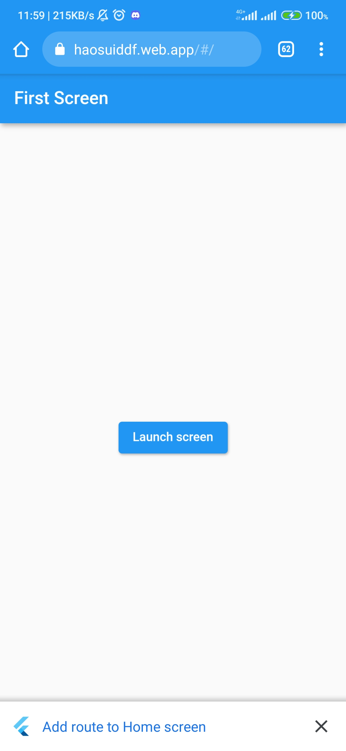

Every flutter web site supports PWA.

*Requirement 57. Support of Community*

Flutter has a large amount of support but not compared to current js frameworks.

*Git star*: 132k

*Fork*: 19k3

*Commit*: 26516

*Contribute*: 933

*Requirement 58. Is testing easy?*

Flutter test provides 3 main types of tests to test the application using flutter_test package.

* A unit test tests a single function, method, or class.

* A widget test (in other UI frameworks referred to as component test) tests a single widget.

* An integration test tests a complete app or a large part of an app.

Details of these 3 types of tests have been estimated previously here.

*Requirement 59. Debug*

Devtools with flutter web does not support features like memory , CPU, performance. Only supports debugging of widgets tree.

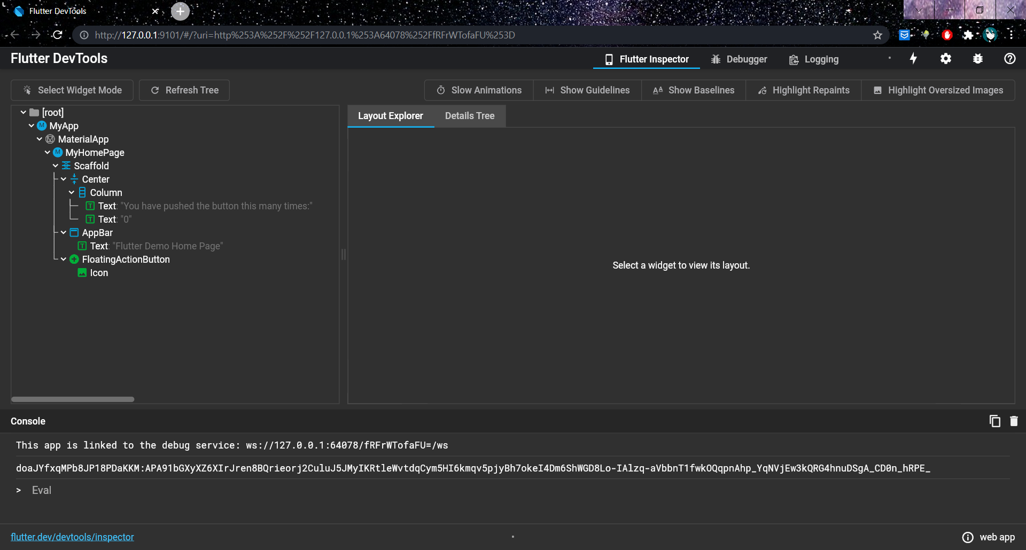

*Requirement 59. Handle vulnerabilities*

flutter handles errors and vulnerabilities well. all vulnerabilities are reported and monitored by GitHub's security advisory to track open security issues

*Requirement 60. Special notes about license*

No special items

*Requirement 61. Evaluation*

Advantages:

* Cross platform is advantageous, but many packages don't work with web platform.

* Document written in full details.

Disadvantages: ​

* Flutter web is new, still under development, many bugs.

* Load size is large, causing slowness, minus points compared to other frameworks.

* Although it is cross platform, many packages do not support flutter web.

* UI library can't compare with current js frameworks

Conclusion:

1. Current web development: not recommended.

2. Future web development: It is easy to move from mobile app to future web once flutter web is stable.

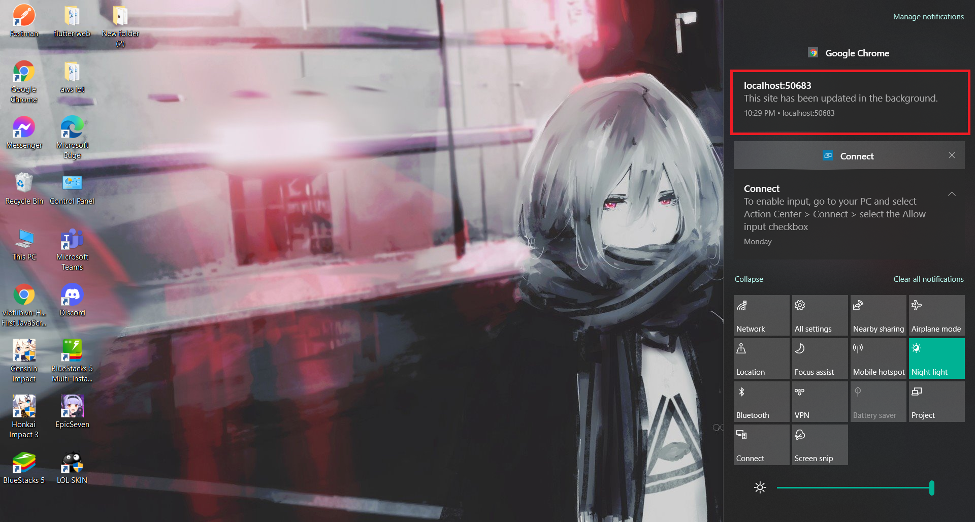

pushnoti